## **Prime Number**

**Program Description:**

Create a program which shows the factors of any integer inputted by the user. The factor outputs must be outputted in both a scrolling textbox as well as a list box. Required operations include finding the sum of factors and whether the inputted number is prime.

**Rubric:**

**“B”**

- factors - sum of factors - number of divisors - 2 ways of output: textbox and list box - prime or not

**“A”**

-GCF -LCM -2 numbers

**Sample output:**

1. Gui before any input:

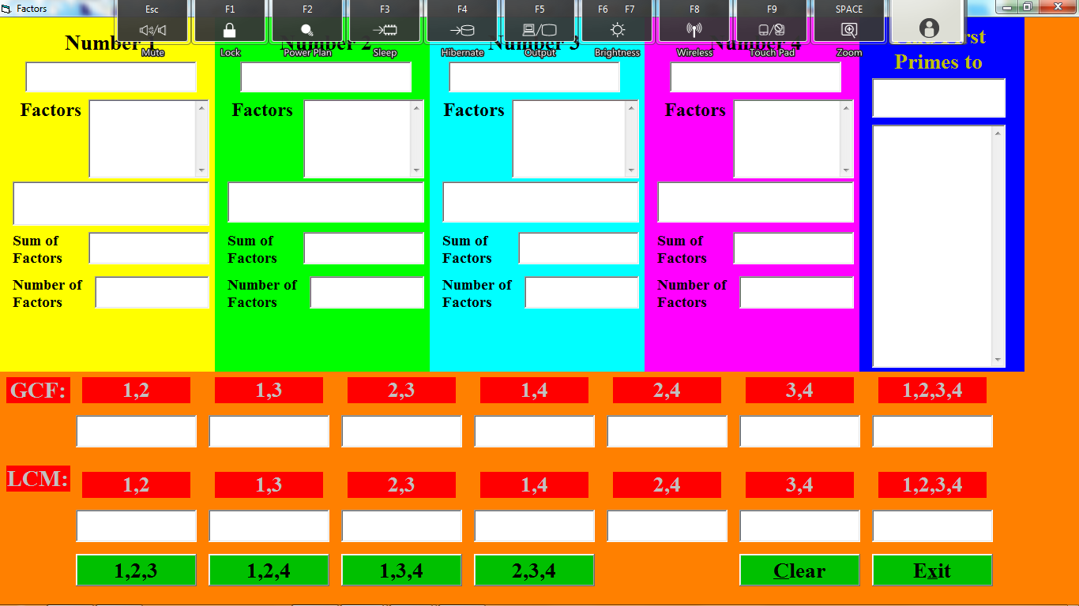

2. Gui after entering in numbers (only need 2 numbers, this project was tryhard)

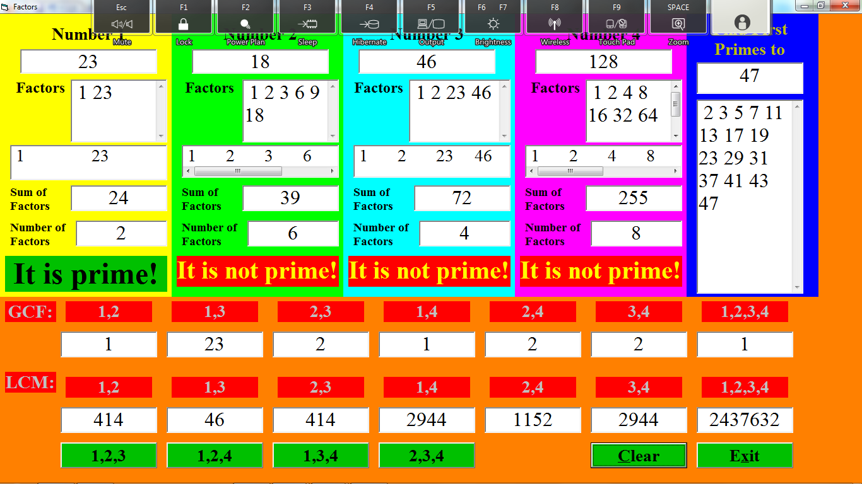

If clear is pressed the program should go back to the way it was in figure 1.